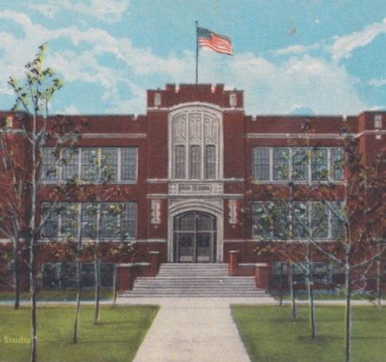

™ & © 2019 AJR Trading Post

09/11 R

**Brownwood**

**Realm**

Valentine’s Edition

**duels**

**Love**

Brownwood is where Austin Robinson came from. It is a realm of… really nothing at all. Laid out across the flattened world in the center of the wilderness, Brownwood was home to Austin for many years before Portland.

AW1 • EN *Design: Austin Robinson*