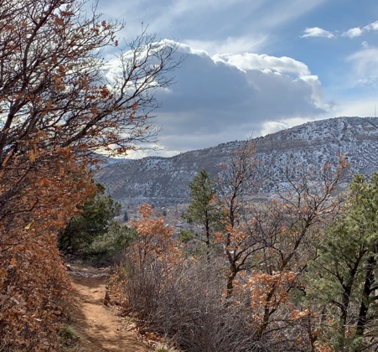

™ & © 2019 AJR Trading Post

05/11 R

**Durango**

**Realm**

Valentine’s Edition

**duels**

**Love**

Durango is where Alexander Wallace hails from. It is a cold realm filled with snow and sunlight. For many years Alexander resided in Durango before trading the snow for rain and the sunlight for darkness in Portland.

AW1 • EN *Design: Austin Robinson*